Chromatof Peak Combination V1.0

User Guide

2017-3-3

1. An introduction to Chromatof Peak Combination

Peak Combination is a green and cross-platform software. It is designed to align and combine peaks from multiple .csv files exported from the Chromatof (LECO, USA) software **(for Pegasus BT instruments only).** The output file (.csv) can be used for further statistical analysis directly.

1. Overview of Peak Combination V1.0
2. Hardware running environment

Computer, RAM at or above 512Mb, CUP Clock Speed at or above 2.4GHz.

1. Software running environment

Windows 7 or above, Mac

Java Runtime Environment at or above 1.3.

(<http://www.oracle.com/technetwork/indexes/downloads/index.html#java>)

1. Compiler language

JAVA

1. Guidance for Peak Combination
2. Program installation

This is a green software. You may copy the EXE file to any location of your computer and do not need to install, if only the environment meets the requirements (JRE 1.3 or above).

1. Access authorization

For first time users, double-click the EXE file and you will see an authorization window. Copy the machine feature code and email it to us. After you fill in the activation code and press OK, the Peak Combination main window will pop up and is ready to serve you. No authorization is required for subsequent usage unless you run it at another computer.

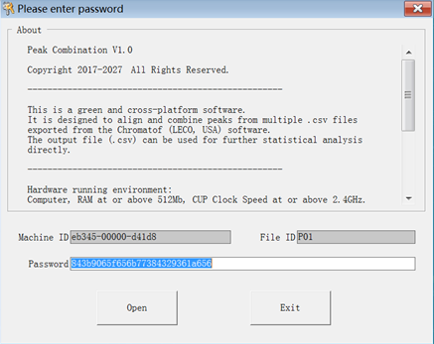

Figure 1 Authorization window

1. Run the program
2. Double-click the EXE file to start the Peak Combination. Then you will see the following window.



Figure 2. Opening window of Peak Combination

1. Click the “Choose model” button, and you will see a window like this. Choose the reference data (.csv). Only 1 data file is permitted.



Figure 3. Choose model file window

1. Click a model file such as A1.csv. Then you will see the file name at the following area. Click the “OK” button.



Figure 4. An example of choosing A1.csv file

The format of your CSV files should be like this (Figure 5). The first row of the columns A, B, C, D, E, F and G should be “Name”, “R.T.(s)”, “Type”, “Similarity”, “Quant Masses” and “Area” respectively.

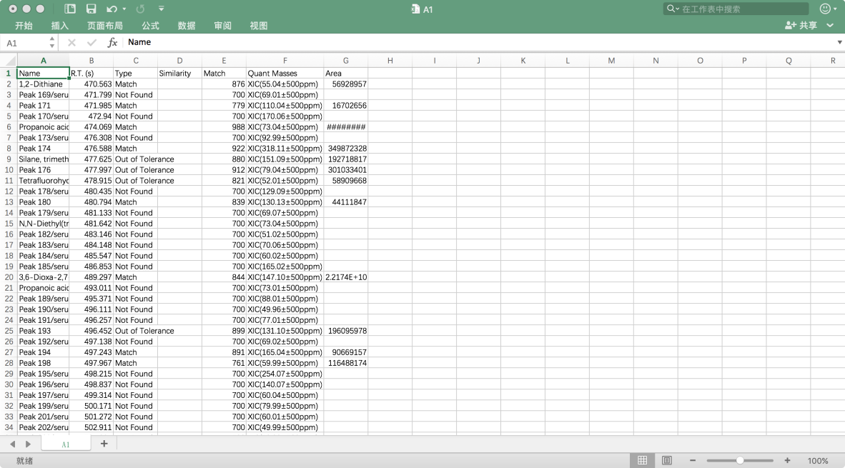

Figure 5. An example of model CSV file

1. After that, you will see the main window like this (figure 6) and the name of your choice will be shown in the lower-middle part of the window.



Figure 6. After you choose a model file

1. Select multiple data files for combination. Click the “Select Input” button, and you will see the following window. Select all the data files which you would like to combine. If you want to choose all the files you can press “Ctrl +A”，or you can choose single file by press “Ctrl”. Then you should click the “OK” button to go back to the main window. (For example we choose A1, A2, A3, A5_2, A6, A6_2, A8_2,A9,A10 as input files. You can see the file name at following area.)



Figure 7. The window of choose input files

1. Then you will see the main window again. The head label will show you how many files have been selected. (For example, we chose 8 files here. The head label showed the message that “xx files have been found”)



Figure 8. Main window after selected the input files

1. Set the percentage value (default if 80%) for peak filtering and press “Enter”. Peaks with zero values in more than 80% samples will be deleted.
2. Click the “RUN” button to start the combination. The process bar shows the process of the combination.



Figure 9. Combination under way.

1. When the progress bar goes to 100%, you will see the saving window. You can change the name and path of the combined file. The default name is “peak_combination” and the default path is the folder of your input files. Click the “SAVE” button to save your settings.



Figure 11. Saving the result

1. Then you will see the following window, and “successful!” at the top. You can click the button of “Cancel” to exit the program or click “Choose model” to start a new combination task.



Figure 12. The finish window of a task

The combined file looks like the example in Figure 13. Each column corresponds to one input file. All the peaks were sorted in descending order by the percentage of zero values.

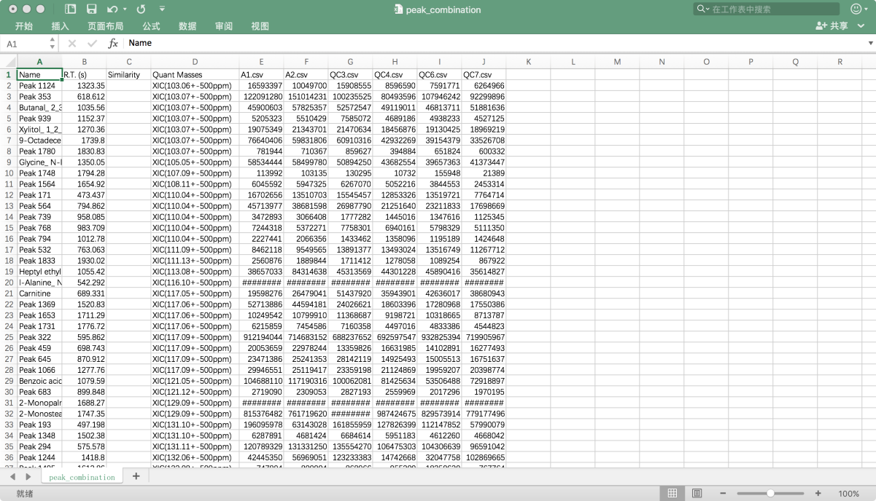

Figure 13. An example of the combined CSV file